PAPER TITLE (HEADING 1 STYLE)
Name and surname of author Name and surname of author Name and surname of author
Abstract: The abstract is a concise summary of the paper (100 to 150 words), enabling readers to grasp its important elements. The Rezime Style should be used for writing the abstract. Keywords come beneath the abstract.
Key words: 5-8 key words

INTRODUCTION (HEADING 2 STYLE)

SECTION (HEADING 2 STYLE)

Subsection (Heading 3 Style)
The paper size is A4 (Portrait). Its margins are set to: Multiple pages-Mirror margins, Top and Bottom 2.5 cm, Inside 2 cm, Outside 3 cm. The number of pages is 4 to 6.
The font used in the paper is Times New Roman, size 11pt with paragraph spacing 6 (Normal Style).
If there are any enumerations in the text, the list should be bulleted and styled like this:
- Bulleted text
- Bulleted text, ...

Subsubsection (Heading 4 Style)
Expressions are indented for 0.5 cm. Functions, variables and Greek symbols are in italics, font size 11 pt, subscripts and superscripts are 7 pt, while symbols are 14 pt.
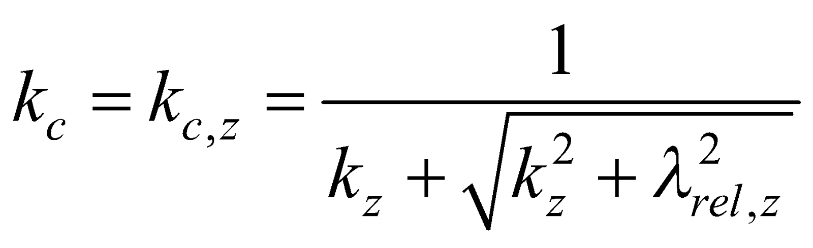 (The expression number is aligned to the right margin.) (1)
Where:
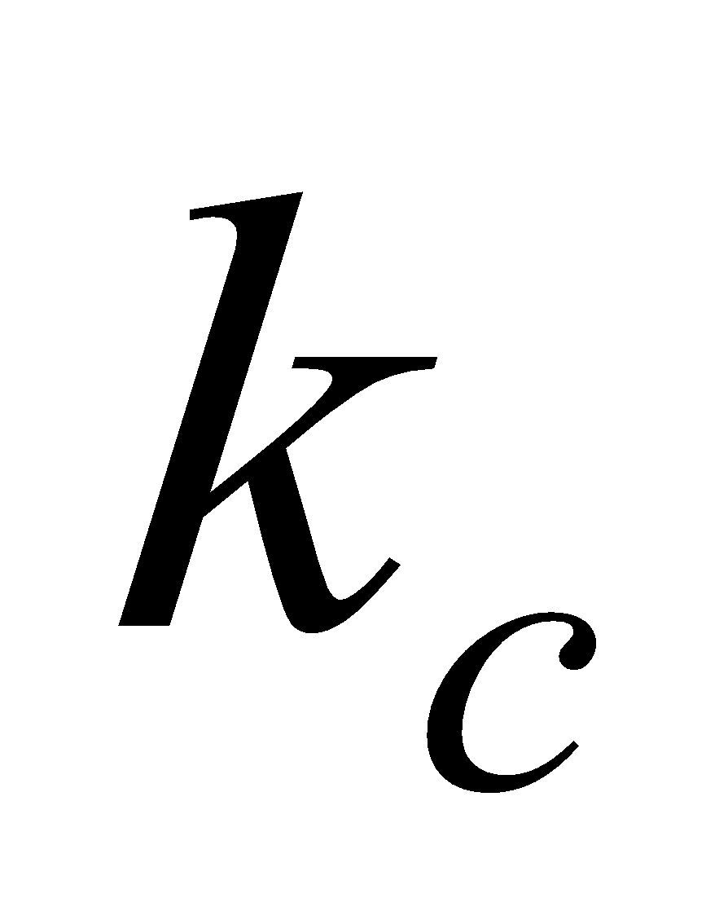– The first variable,
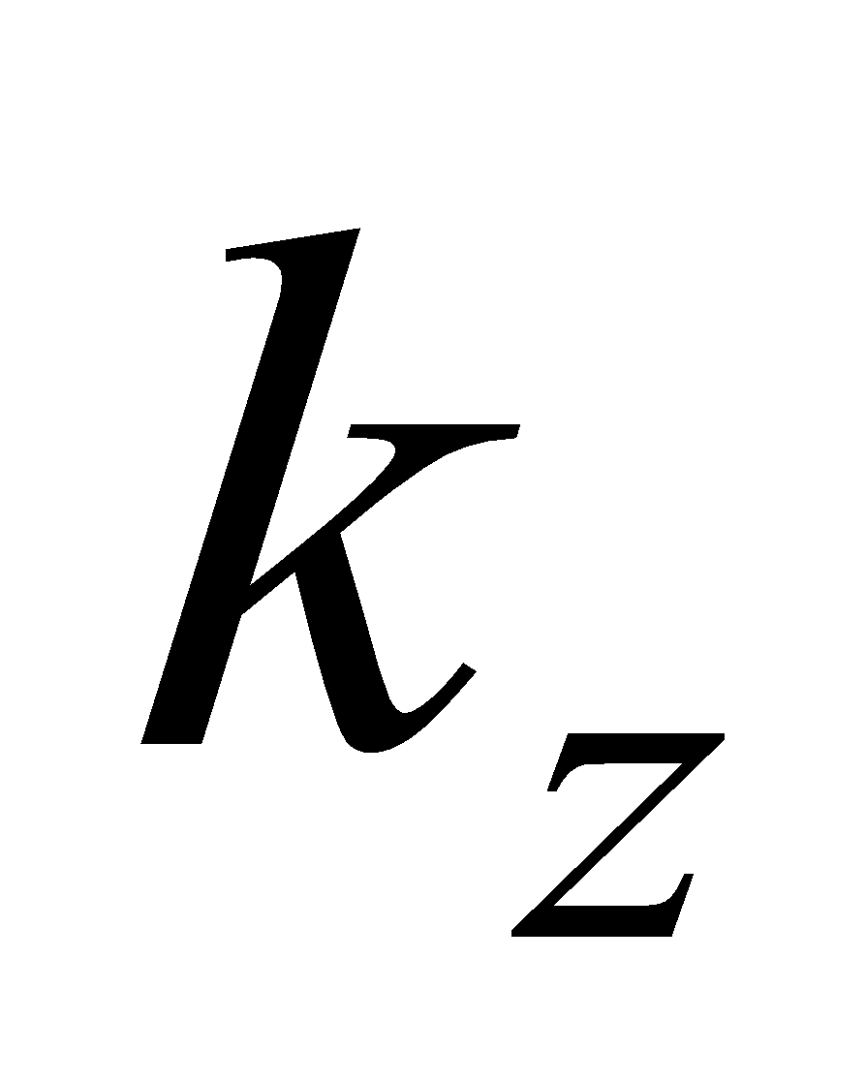– The second variable, ...

For the text inside tables use Table Style, and for table and picture titles use Caption Style.
For displaying tables use the option Insert table, with line thickness 1/2 pt, and shaded heading (Design→Borders→Borders and shading→Shading→Style = 10%). Before the table title and beneath the table leave one empty row. The word Table is capitalized in the text.

Table 1 − Table title

The quality of images has to be as good as possible (scanned images are not acceptable). Diagrams, graphics, drawings and images must be sent in their original form along with the paper. In the text, all illustrations are figures, and the word Figure is capitalized.
Before the Figure and beneath the Figure title, leave one empty row.


Figure 1 − Figure title

CONCLUSION

REFERENCES
Only sources used in the paper preparation can be mentioned in the reference list. Arrange the references in the order of appearance in the document. When referring to literature, use the reference number in square brackets in the appropriate place in the text. In case of citing multiple sources at a time, each reference number is in its brackets separated by a comma [2], [3], or a dash [1]-[3]. To format the bibliography, use the References icon, which automatically performs numbering. The following are examples of correctly cited literature.
- Montgomery, D. C. (author): Design and Analysis of Experiments (9th ed.) (work), John Wiley & Sons (publisher), New York (town), 2017 (year).
- Atkins, P.; Jones, L.: Chemical Principles: The Quest for Insight (7th ed.), W. H. Freeman and Company, New York, 2016.
- Demirbas, A.: Combustion Characteristics of Different Biomass Fuels, in Energy Conversion and Management, Vol. 52 (3), Elsevier, 2011, pp. 1927–1933.
- Ware, M.: The Cyanotype Process: John Herschel’s Discovery and Modern Practice, available at: http://www.mikeware.co.uk/mikeware/John_Herschel.html, November 2011.
- European Chemicals Agency (ECHA): Regulation (EC) No 1907/2006 (REACH) on the Registration, Evaluation, Authorisation and Restriction of Chemicals (“Official Journal of the European Union”), 2020.
- European Commission: Classification, Labelling and Packaging (CLP) Regulation (EC) No 1272/2008 — List of Harmonised Classification and Labelling of Hazardous Substances (“Official Journal of the European Union”), 2021.
Acknowledgements: In this section, you can acknowledge any support given which is not covered by the author contribution or funding sections. This may include administrative and technical support, or donations in kind (e.g., materials used for experiments).

Please save your paper as Surname-AHEAD-2026.doc written according to the provided guidelines and submit it using the online upload form no later than January 10th, 2026 or send it to marketing.nat@gmail.com.

Title, institution and address, email:

